SWT 22022 – Practical for Internet Application Development
Department of Information and Communication Technology
Faculty of Technology
Lab sheet :12
Reg. Number: SEU/IS/20/ICT/084
Academic Year :2020/2021
Date: 2024.10.02
Practical No :12

Title: Introduction to PHP framework (Laravel)
Aims:
• Setting up development environment
• Database connectivity
• Project creation
• Understanding the Laravel’s core concepts
• Project structure navigation
Tasks:
• Install PHP
• Install Laravel and Composer
• Create a Laravel project
• Navigate through Laravel documentation and architecture
• Introduce Laravel database
• Review of Laravel file structure
Activities :
1. Install PHP

On Linux and macOS, PHP is typically pre-installed. To check the version of PHP installed, run the following command:

php -v
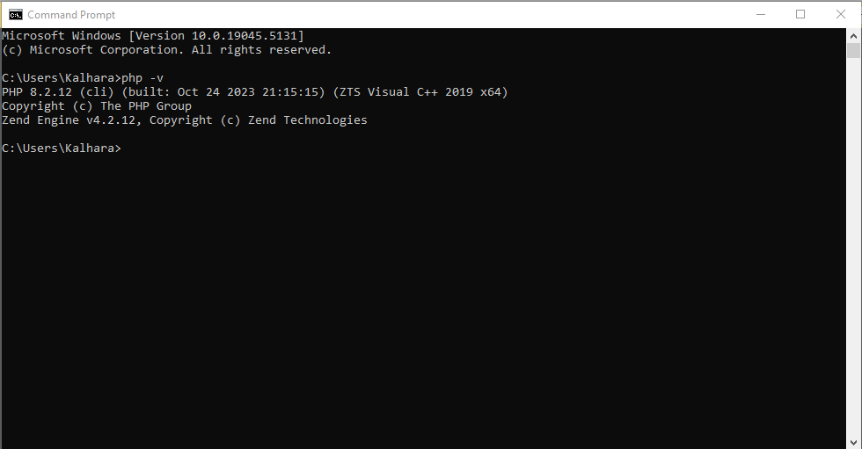

If PHP is not installed, you can install it using your package manager.
On Ubuntu, you can install PHP with the following command:

sudo apt install php

On Windows , You can refer this documentation :

https://windows.php.net/download

2. Install Laravel and Composer

https://getcomposer.org/doc/00-intro.md
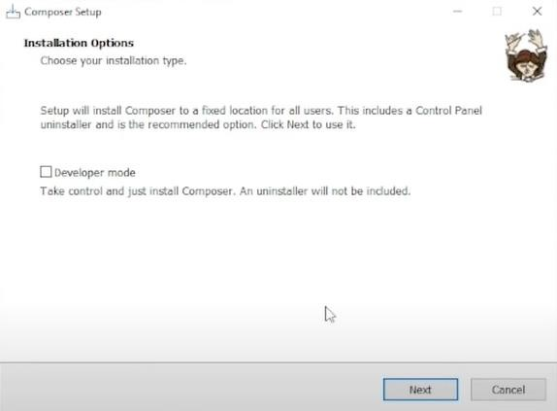

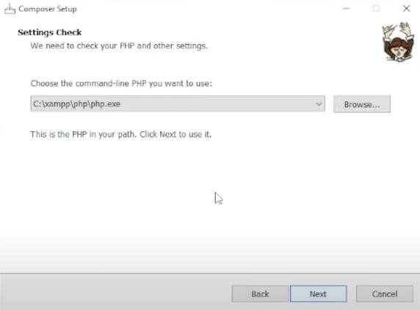
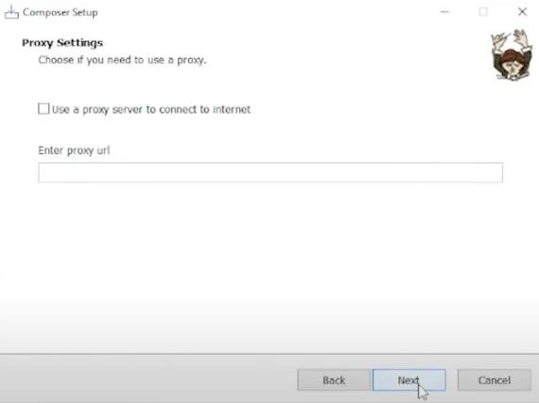

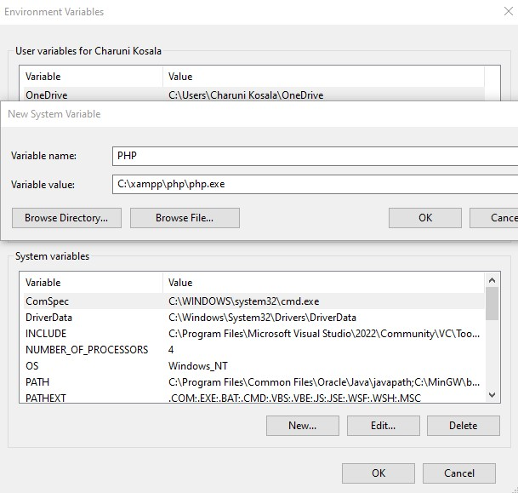
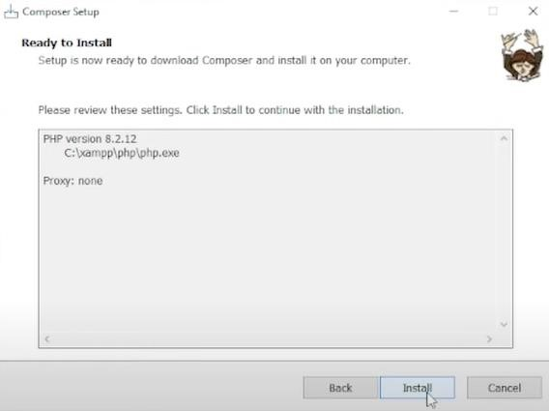

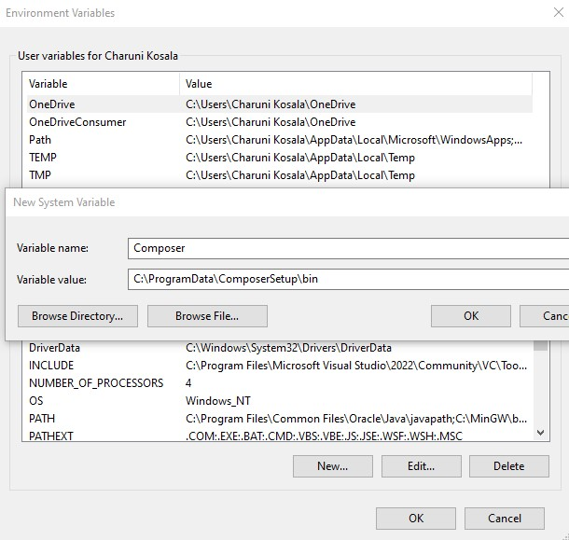

. To check the version of PHP installed, run the following command:

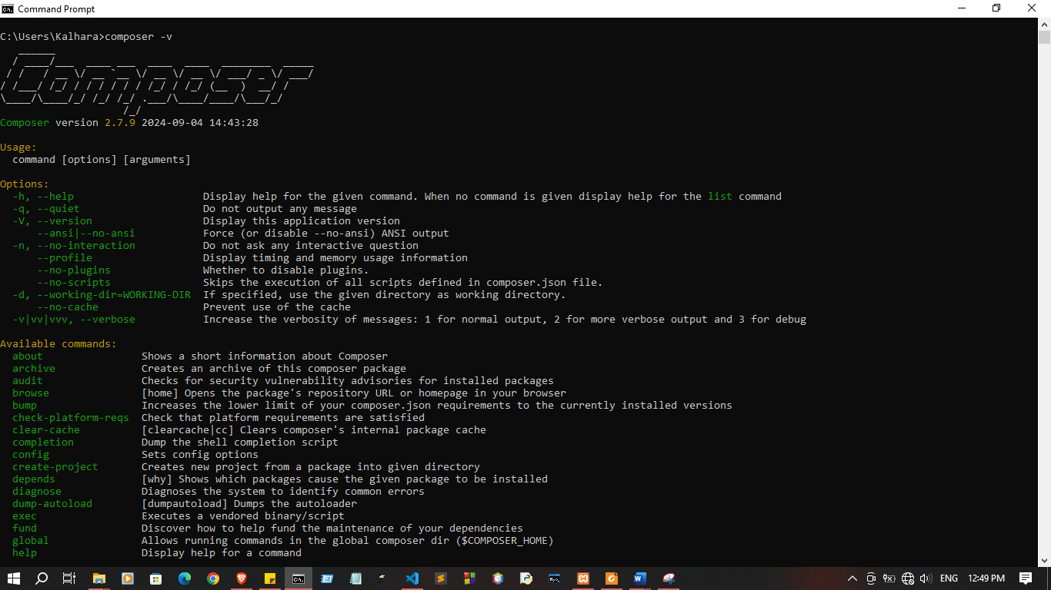
composer –version

3. Install Laravel
To install Laravel, run the following command:

composer global require laravel/installer
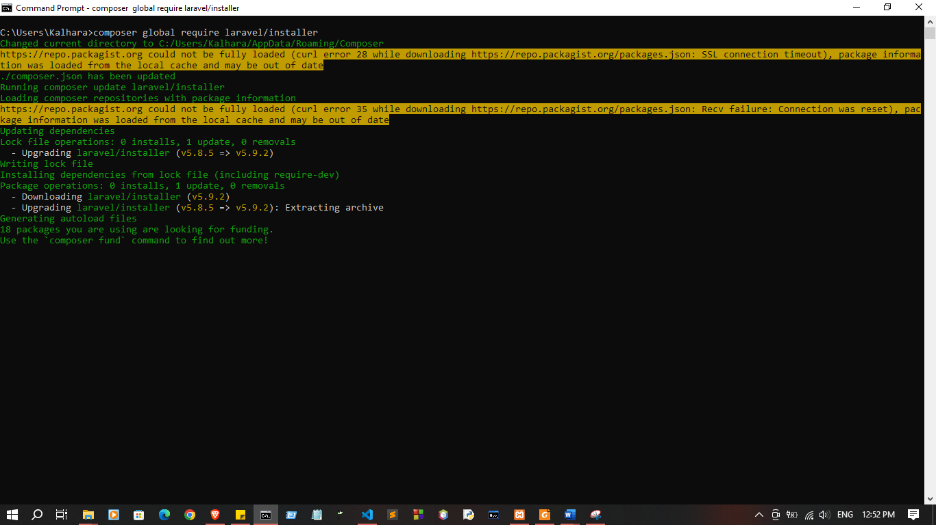

Do these changes in php.ini file
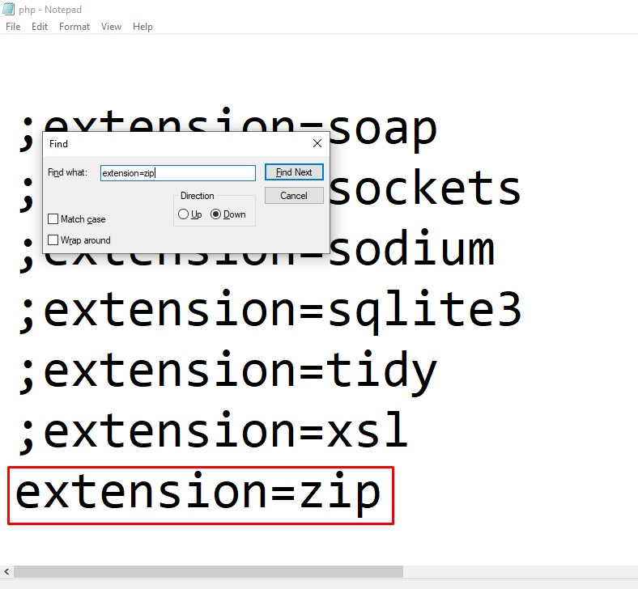

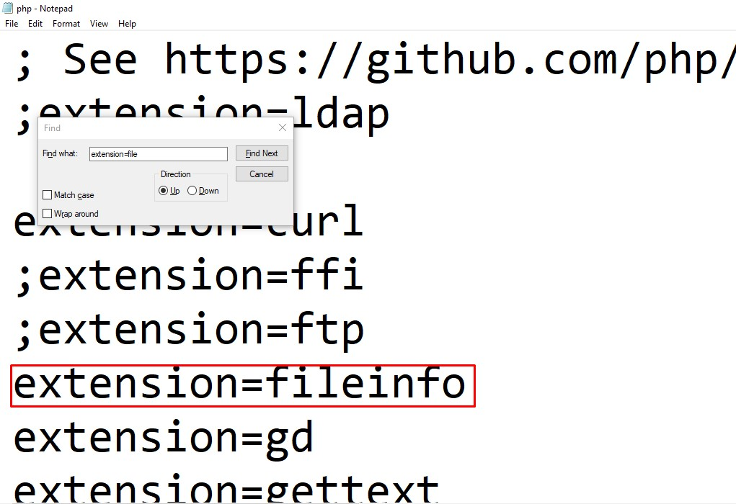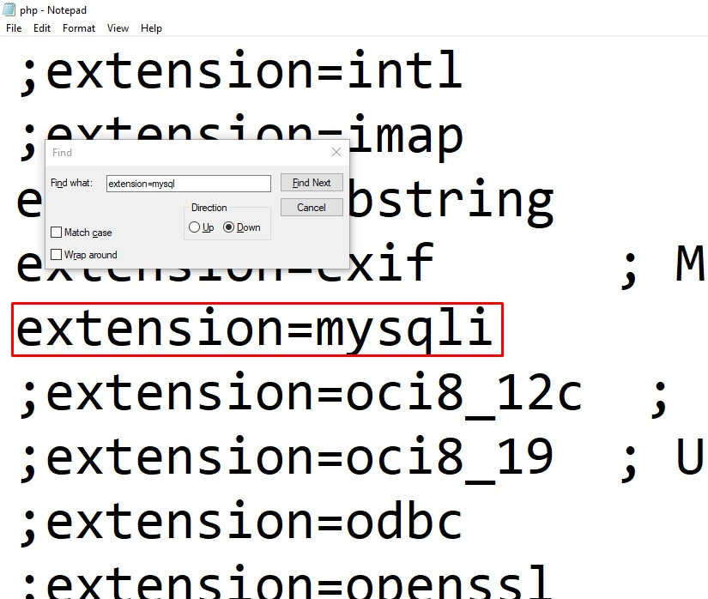

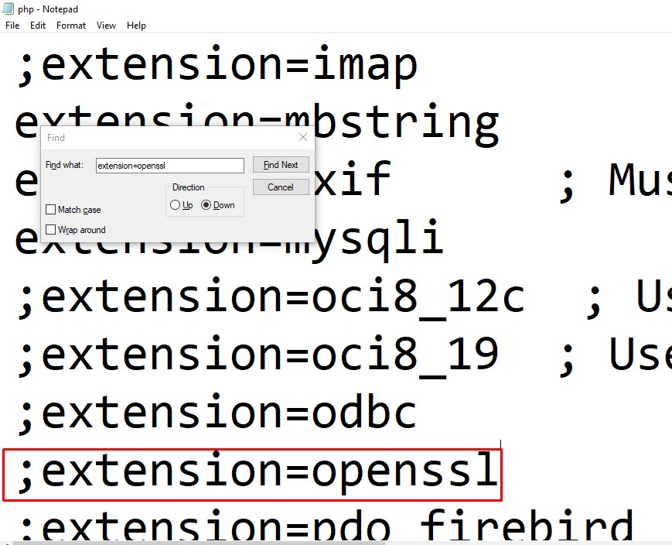

4. Create Laravel project

Use this command :

laravel new example-app
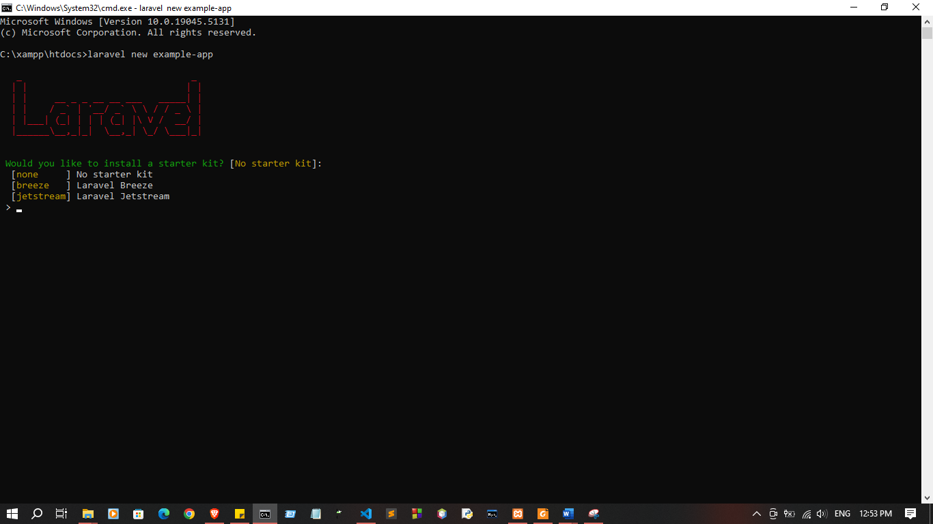

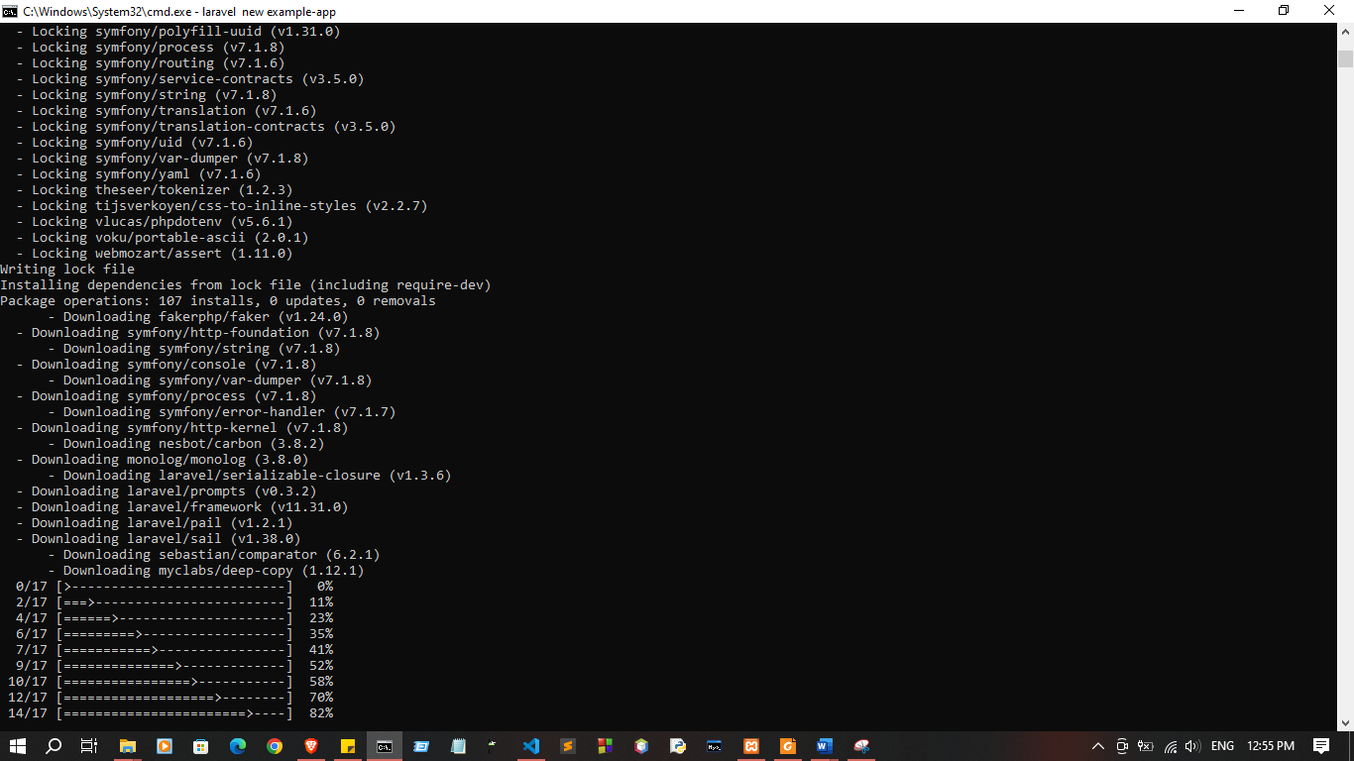
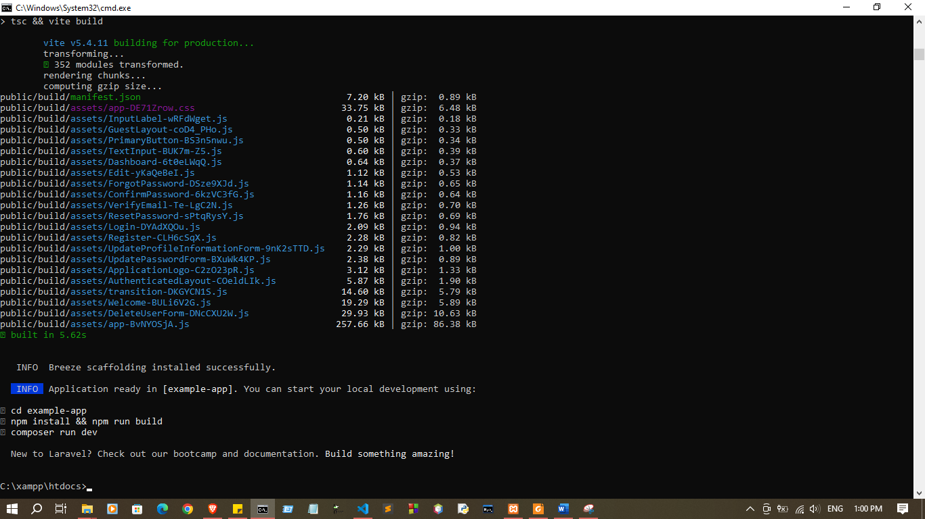
Run the project :
cd example-app
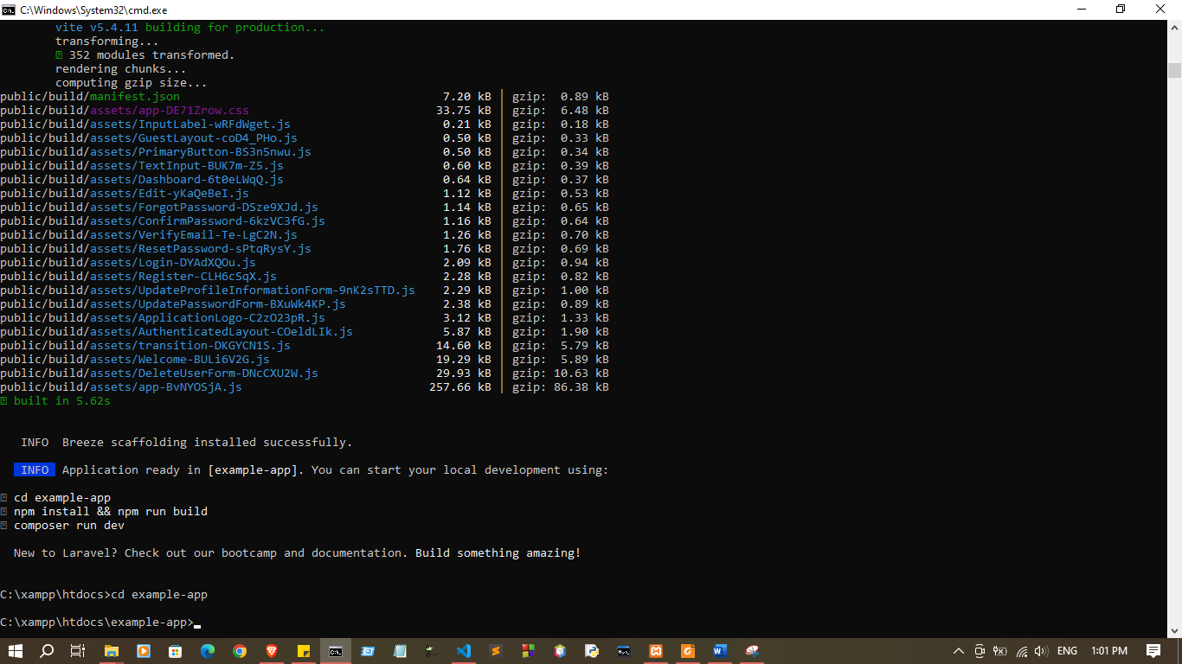

php artisan serve
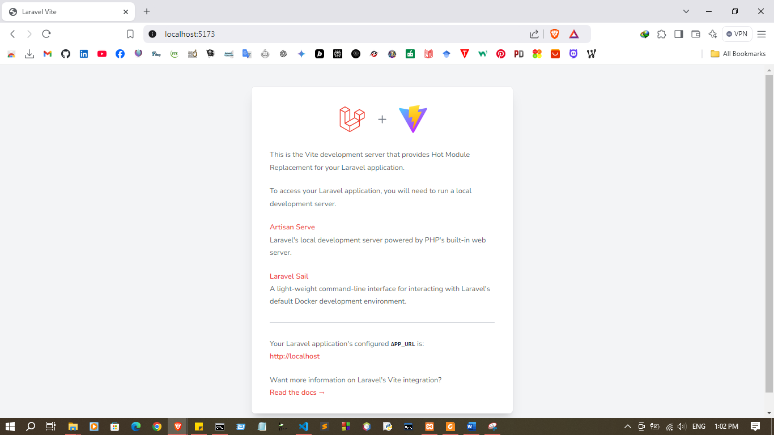

- Navigate through Laravel documentation and architecture

The Laravel documentation is a comprehensive resource for learning about all aspects of the Laravel framework. It can be found at the following URL:

https://laravel.com/docs/11.x

The documentation is divided into several sections, including:
  - Getting Started: This section covers the basics of Laravel, such as setting up a new project, routing, and controllers.
  - Views: This section covers how to create and render views in Laravel.
  - Blade: This section covers the Blade templating engine, which is used to create views in Laravel.
  - Artisan: This section covers the Artisan console, which provides a number of helpful tools for managing Laravel applications.
  - Eloquent: This section covers Eloquent, the Laravel ORM, which makes it easy to interact with databases.
  - Authentication and Authorization: This section covers how to implement authentication and authorization in Laravel applications.
  - Testing: This section covers how to write and run tests for Laravel applications.
  - Deployment: This section covers how to deploy Laravel applications to production servers.

Architecture:

Laravel is a full-stack web framework, meaning that it provides all of the tools needed to develop web applications including:
  - MVC architecture: Laravel uses the MVC architecture, which separates the application into three layers: models views, and controllers. This makes the code more modular and easier to maintain.
  - Routing: Laravel provides a robust routing system that allows you to define how your application responds to different HTTP requests.
  - Templating: Laravel uses the Blade templating engine, which is a powerful and flexible way to create views.
  - Database abstraction layer: Laravel provides Eloquent, the Laravel ORM, which makes it easy to interact with databases.
  - Authentication and authorization: Laravel provides built-in support for authentication and authorization, making it easy to secure your applications.
  - Testing framework: Laravel provides a built-in testing framework that makes it easy to write and run tests for your applications.

- Introduce Laravel Database

https://laravel.com/docs/11.x/eloquent

php artisan make:model Employee -m
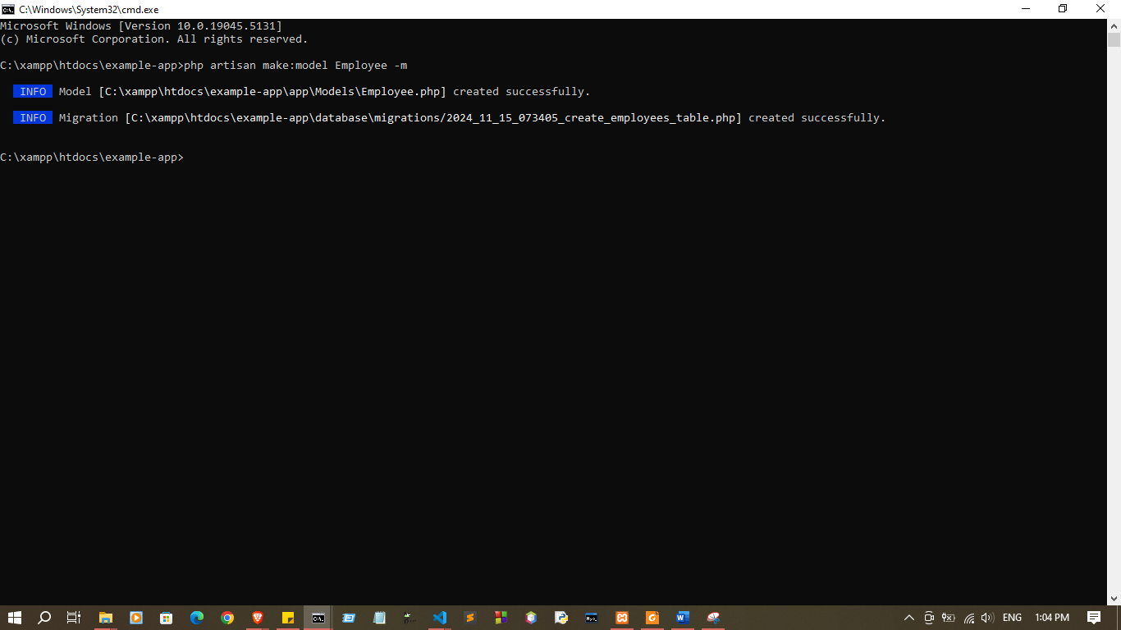

public function up()
{
Schema::create('employees', function (Blueprint $table) {
$table->id();
$table->string('first_name');
$table->string('last_name');
$table->string('email')->unique();
$table->string('phone')->nullable();
$table->string('position');
$table->decimal('salary', 8, 2);
$table->date('hired_date');
$table->timestamps();
});
}

<?php

use Illuminate\Database\Migrations\Migration;
use Illuminate\Database\Schema\Blueprint;
use Illuminate\Support\Facades\Schema;

return new class extends Migration
{
/**
* Run the migrations.
*/
public function up()
{
Schema::create('employees', function (Blueprint $table) {
$table->id();
$table->string('first_name');
$table->string('last_name');
$table->string('email')->unique();
$table->string('phone')->nullable();
$table->string('position');
$table->decimal('salary', 8, 2);
$table->date('hired_date');
$table->timestamps();
});
}

/**
* Reverse the migrations.
*/
public function down(): void
{
Schema::dropIfExists('employees');
}
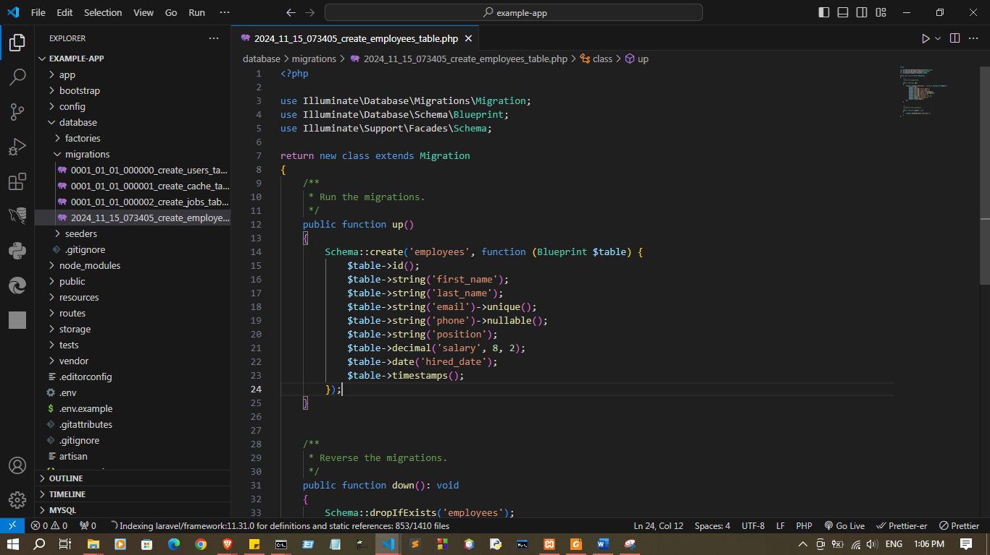
};

Discussion:
- This lab practical session focuses on gaining a foundational understanding of Laravel, a widely used PHP framework. The session begins with setting up the development environment by installing PHP, Composer, and Laravel. Students will create a Laravel project to explore its core concepts, such as routing, controllers, and middleware, while also familiarizing themselves with the framework's organized project structure. Emphasis will be placed on understanding Laravel's database connectivity and how it simplifies interaction with databases using its built-in ORM, Eloquent. By navigating the Laravel documentation and exploring the file structure, participants will develop a hands-on appreciation of the framework’s architecture, preparing them for more advanced tasks in future projects

